The SeatWeavers’Guild,Inc.®
Renewals & New Memberships
July 1, 2017 to June 30, 2018
http://SeatWeaversGuild.org

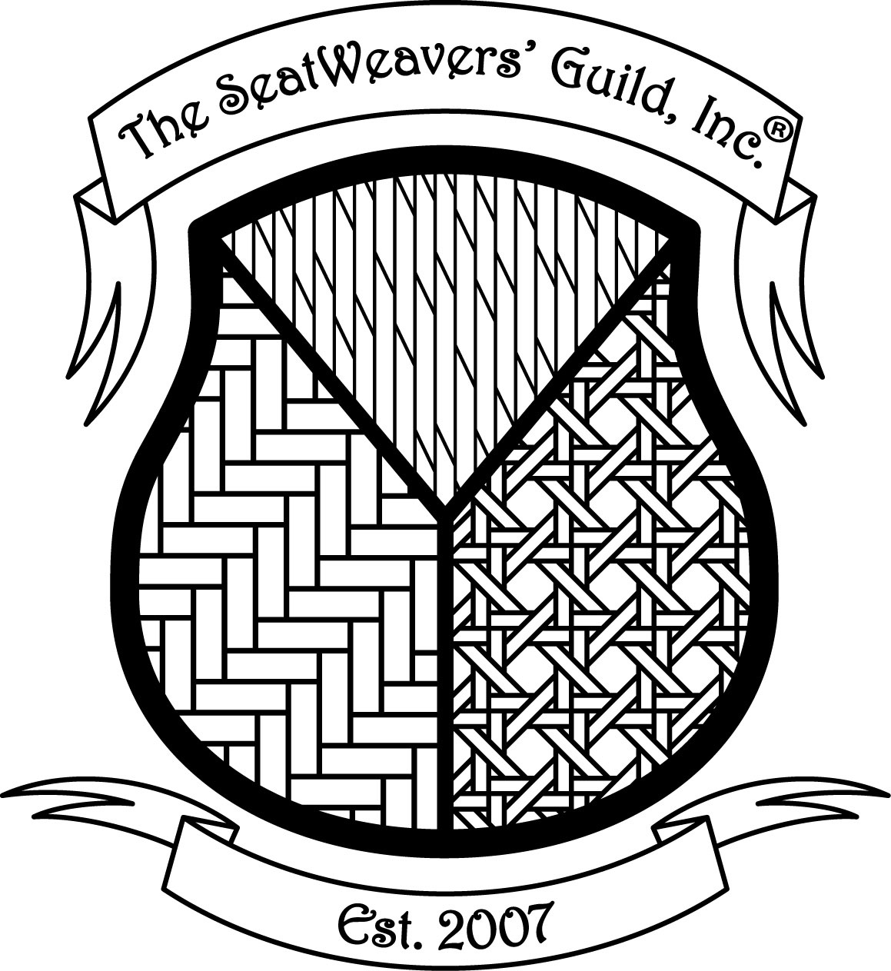

Individual level and all others, receive the quarterly newsletter,
membership roster, notices of events and annual meeting/workshop, access to our members only section of the website.
Cottage level also receives business listing in newsletter;
Business level also receives listing in newsletter and link on TSWG website;
Corporate level also receives ad space in both newsletter and on website.

Name: | Home phone:
Business:  (Please include a business or calling card) | Business phone:  Fax:
Address: | Cell phone:
City: | Email address:
State: Zip+4: | Website:

Join us or Renew your Membership today!
Online:
“SeatWeaversGuild.org”
Or
Make a check or money order (in US Funds) payable to:
The SeatWeavers’ Guild, Inc.®

Mail check & completed application to:

Rhonda Voos
TSWG Membership Chair
96 Bayard Ave
North Haven, CT 06473
(203) 7766310
Email:rvoos@marrakechinc.org
or: Info@SeatWeaversGuild.org
Please choose your membership level:
Dues are in USD

____Renewal ____New Member

___ Individual $30

___ Cottage $50

___ Business $75

___ Corporate $100

International Please add $10

